CS-005 CNC Machining of Tooling Board (ShopSabre)
Doc ID | CS-005
Title | CNC Machining of Tooling Board (ShopSabre)
Revision | F
Status | Draft, pending Lead signature
Effective date | 2026-10-10
Supersedes | Jacobs Shopbot as primary mold machine (see Appendix); Shopbot Procedure Checklist still applies to the Shopbot when we use it

Approvals
Role | Name | Date
Author | Simon Starbuck (drafted with Claude, SN6 Resources) | 2026-07-12
Reviewer | simon (reviewer agent) | 2026-10-10
Approver (Composites Lead)

Revision history
Rev | Date | Author | Description of change
A | 2026-07-12 | Claude | Initial issue
B | 2026-07-13 | Claude | Corrected machine facts: 5×10 bed (not 4×8), vacuum hold-down, automatic tool changer w/ auto tool measurement; zeroing section rewritten around the ATC
C | 2026-07-28 | Claude | Added a dated 2026-07 web cross-check on the R2 ShopSabre spec citation (doesn't resolve the placard-confirm open item, just documents it); sharpened the certified-operator list caveat against a real discrepancy found in sn5-work-orders.json. Language pass (fewer em dashes, less decorative bold).
D | 2026-08-03 | Claude | §7.5 now engraves the mold ID on the back face before releasing the vacuum, while the setup still exists. This is the record of record (CS-001 §7.4).
E | 2026-08-28 | Claude | Engineering pass (CS-000 Rev C conventions). Figure 1 draws the Z-zero rule right and wrong; it replaces the photo placeholder, which showed the same thing less clearly. No rule changed.
F | 2026-10-10 | Claude (doc overhaul, requested by Simon Starbuck) | Rule changes: RFS's record is the operator authority and the app's ShopSabre CNC training mirrors it; Z is zeroed once per setup, so each split section is its own setup; CAM uses the current FEB tool library; feeds are set for the densest board; scope adds XPS foam, G10 and cured CF panels. The app written in where the standard predated it: Schedule slot rows and the weekly meeting (R-000-11), the Machine mold step note, the mold's stage, Mold file and stock STL at the machine, the split waiver in §5, and a pointer to stack planning in CS-003. References updated; title field matches the H1 (R-IDX-04), kept as the H1 (ShopSabre) with "at RFS" not added, to keep the built filename; emphasis bold and em-dash cells dropped; §7.1 and §7.5 headings reworded for search. Round 6 fact-check: the ID is engraved before cleanup (§7.5 steps 4 and 5 swapped, so the setup still exists); the 6 in cut depth cited to the app's planner rather than to R2; §6 adds safety glasses at the machine from the tooling-board SDS (new R6). Register R-005-01..12.

1. Purpose
We spent most of SN5 machining molds on the Jacobs Shopbot's daily slot scramble, right up until Jacobs staff pulled us aside for block-reserving (2026-02-23). That's not a conversation we want to have twice (PP-06). We now machine on the ShopSabre at RFS, with our own reservation system, a 5×10 ft bed, vacuum hold-down, and an automatic tool changer. This doc covers how to book it, who can run it, and the setup rules that cost us parts when we skipped them.

2. Scope
Machining polyurethane tooling-board molds and stock on the RFS ShopSabre. The same booking, operator and Z-zero rules apply to XPS foam (wing cores), G10 and cured CF panels cut on the ShopSabre. G10 runs only with Larry's say-so. CF and G10 dust is handled per CS-009. The Jacobs Shopbot is still fine as a fallback for small jobs; use the SN5 Shopbot Procedure Checklist there (that machine has none of the features below; everything is manual).

3. References
Ref | Document | Where
R1 | RSO/RFS hub: reservation site (booking) and ShopSabre training doc | sites.google.com/berkeley.edu/rsorfs-hub (linked in #composites, 2026-09-18)
R2 | ShopSabre 5×10 specs (IS-A 510 class) | shopsabre.com product pages, accessed 2026-07. Re-checked 2026-07-28: the current IS-A 510 page quotes a 75″×125″ table and 12″ Z clearance / 16″ Z travel, which doesn't line up cleanly with the 65.5″×122″ / 14″ figures below (the 6 in max cut depth in §5 is the app's planning depth, not from R2). Treat both as generic spec-sheet numbers, not a measurement of RFS's specific machine with its actual tooling stickout; confirm the real numbers on the placard before trusting either source over field experience
R3 | Shopbot Procedure Checklist (fallback machine) | SN5 Composites/Shopbot Procedure Checklist_.docx
R4 | PP-06 RCA; Z-plunge incidents | FEB-COMP-PP-001
R5 | CS-003 (mold design/stock), CS-004 (post-machine cleaning) | this series
R6 | Precision Board PBLT SDS (tooling board) | 03 Datasheets/PRECISIONBOARD-SDS-PBLT.pdf

4. Definitions
- HOT: RFS hands-on-training sign-off; required before you run the machine on your own.
- Certified operator: did the RFS ShopSabre training doc + HOT. RFS's own record, on the RSO/RFS student access dashboard, is the authority. The app's ShopSabre CNC training (People tab) mirrors it: a lead grants it only after seeing the member's RFS record. The app will not let anyone without it sign Machine mold, except a lead who presses Sign without it and writes a reason, which the app records on the work order (app/workorders.js). The end-of-SN5 list (Ansh, Simon, Kina, Nico, Nick, Justin, Sam, Alvin, Ernesto) is history, not a roster. Re-check who's still around each fall and train replacements early, October not February.
- CAM review: Larry requires whoever is machining to have made their own CAM, and he reviews it before it runs. Build this into the schedule; it has saved us more than it has cost us.
- ATC: automatic tool changer. The machine swaps tools from its rack mid-program and measures each tool's length automatically, so tool changes don't need a manual re-zero.

5. Equipment & Materials
Item | Spec | Notes
ShopSabre CNC router (5×10) | Cut area ≈ 65.5″ × 122″, Z travel 14″ (spec figures from R2's 2026-07 access, unconfirmed on the placard; see R2 note); max cut depth 6 in (152.4 mm), the depth the app plans to (app/slicer.js) | Full 5×10 sheets fit flat: no more sectioning sheet stock. The app splits any mold stack over 6 in into sections unless the split is waived (CS-003 §7.1 step 6; app/slicer.js). A waived stack is taller than 6 in: before the first setup, check the deepest machined point against the tool's flute length and collet clearance. The 6″ is what this team has actually gotten out of the machine with real tooling installed, which is the number that matters here, not a frame spec; confirm usable depth against your tool length before gluing a tall stack
Vacuum hold-down table | Zoned vacuum through the spoilboard (R2) | Sheet stock and boards hold with no tape or nails. See 7.3 for when vacuum alone isn't enough
Automatic tool changer | Tool rack + automatic tool length measurement (R2) | Tool offsets live in the controller's tool table; see 7.4
End mills / collets | Per CAM plan | Inspect before use; tell Larry if a tool in the rack looks tired
Dust extraction | Machine system | PU dust rules in §6

6. Safety
- Machine: hands away from a live spindle; know where the e-stop is before every run; watch the first minutes with a hand near it. Max 2 people at the machine during setup (kept from the Shopbot rules; still a good rule).
- Tooling-board dust: abrasive and irritating. Extraction on, dust mask minimum (respirator for long jobs). Vacuum shared rooms; don't blow dust around with compressed air.
- Eyes: safety glasses at the machine whenever the spindle runs or you clear chips (R6 §8: standard safety glasses).
- Vacuum table: don't reach under a held part to "check" it while zones are on; release zones first.

7. Procedure

7.1 Booking the ShopSabre
- When mold CAM starts (not when it finishes), write the machining time estimate in the work order's Machine mold step note (Glue and machine mold on a wet-layup run; there is no estimate field) and book the slot on the RFS/RSO site (R1). Our SN5 UT molds ran 0:17–6:16 each; CAM simulation gets you a real number.
- Book under the name of whoever is actually running the machine. RFS rule: you attend your own reservation. No covering slots for each other; that's the exact thing that burned us at Jacobs.
- Booking-site quirks (as of spring 2026): multi-day and some short blocks fail: book day-by-day chunks and report bugs to Joey.
- Put the job in a ShopSabre slot row (ShopSabre slot 1 or ShopSabre slot 2) on the Schedule tab, Season by station view. The row is the team's plan and does not reserve the machine; step 1 does. The weekly meeting reviews the next 2 weeks of machine load, so conflicts show up there, not at the machine.
- The stack plan, and the blanks used as CAM stock, come from CS-003 §7.1 steps 8 and 9 (the app's planner or the FEBPlanStock Fusion add-in).

7.2 Prerequisites at the machine
- Certified operator, running their own CAM, reviewed by Larry (R1).
- Mold design review initialed on the WO (CS-003 §7.2). No initials, no machining.
- Stock glued/cured per CS-003 §7.3 and labeled, and check the label is actually the job you booked. The mold is at Board glued in the app.
- The mold's Mold file is the current plan, not one marked Superseded (CS-003 §7.1 step 8).
- CAM stock is the plan's Stock STL (STL S1, STL S2 and so on, one per section of a split stack) or the Fusion add-in's blank bodies, so the program and the glued block agree.

7.3 Workholding (vacuum table)
- Sheet stock and flat boards: place on the spoilboard, open the zones under the part, keep unused zones closed for suction where it counts. No tape, no nails.
- Tall glued mold stacks with small footprints are the case to think about: holding force scales with footprint area, and a 6″ stack on a small base sees real side loads. Do a firm hand-push test before running; if it moves at all, add mechanical fixing (screws through waste margin into the spoilboard, or cleats) and note it in the CAM so nothing cuts there.
- Porous/already-sealed surfaces hold differently. When in doubt, test-push and ask Larry.

7.4 Zeroing and tooling: where SN5 lost parts
- Zero Z once per setup, from the top of the stock, at the highest point of the finished stack. Never the bed. (The Feb 2026 "it plunged into the part" incidents were zeroing mistakes on the old machine; the rule carries over.) Each section of a split stack is its own setup, with its own stock STL and its own zero.
- Tool changes are the ATC's job, not yours. The machine measures each tool's length and applies offsets from the tool table: there's no manual re-zero between tools. What that means for you:
- Build CAM against the current FEB ShopSabre tool library (posted in #composites 2026-09-16; the older library is deprecated). A tool table that does not match the rack does the same thing a bad zero does, just faster.
- If anyone has manually swapped a bit in a rack position, the tool must be re-measured before your program trusts it. When in doubt, run the tool-measure cycle; it costs a minute.
- Verify X/Y zero against the stock corner and the CAM origin before starting.
- Deep cuts: split toolpaths into depth stages rather than one full-depth pass.
- Watch the first minutes of every program, hand near the stop.
- Set CAM feeds for the highest board grade in the stack: the mold's Highest density cut once its boards are marked cut, or the top of its planned density range before then (CS-003 §5). The cut list prints it as "Machine at the N lb/ft³ feed." and the layer sheets repeat it (app/stock.js, app/drawings.js).
⚠ CAUTION: Machine doing anything unexpected: stop first, figure it out second. A scrapped hour is cheaper than a scrapped mold stack.
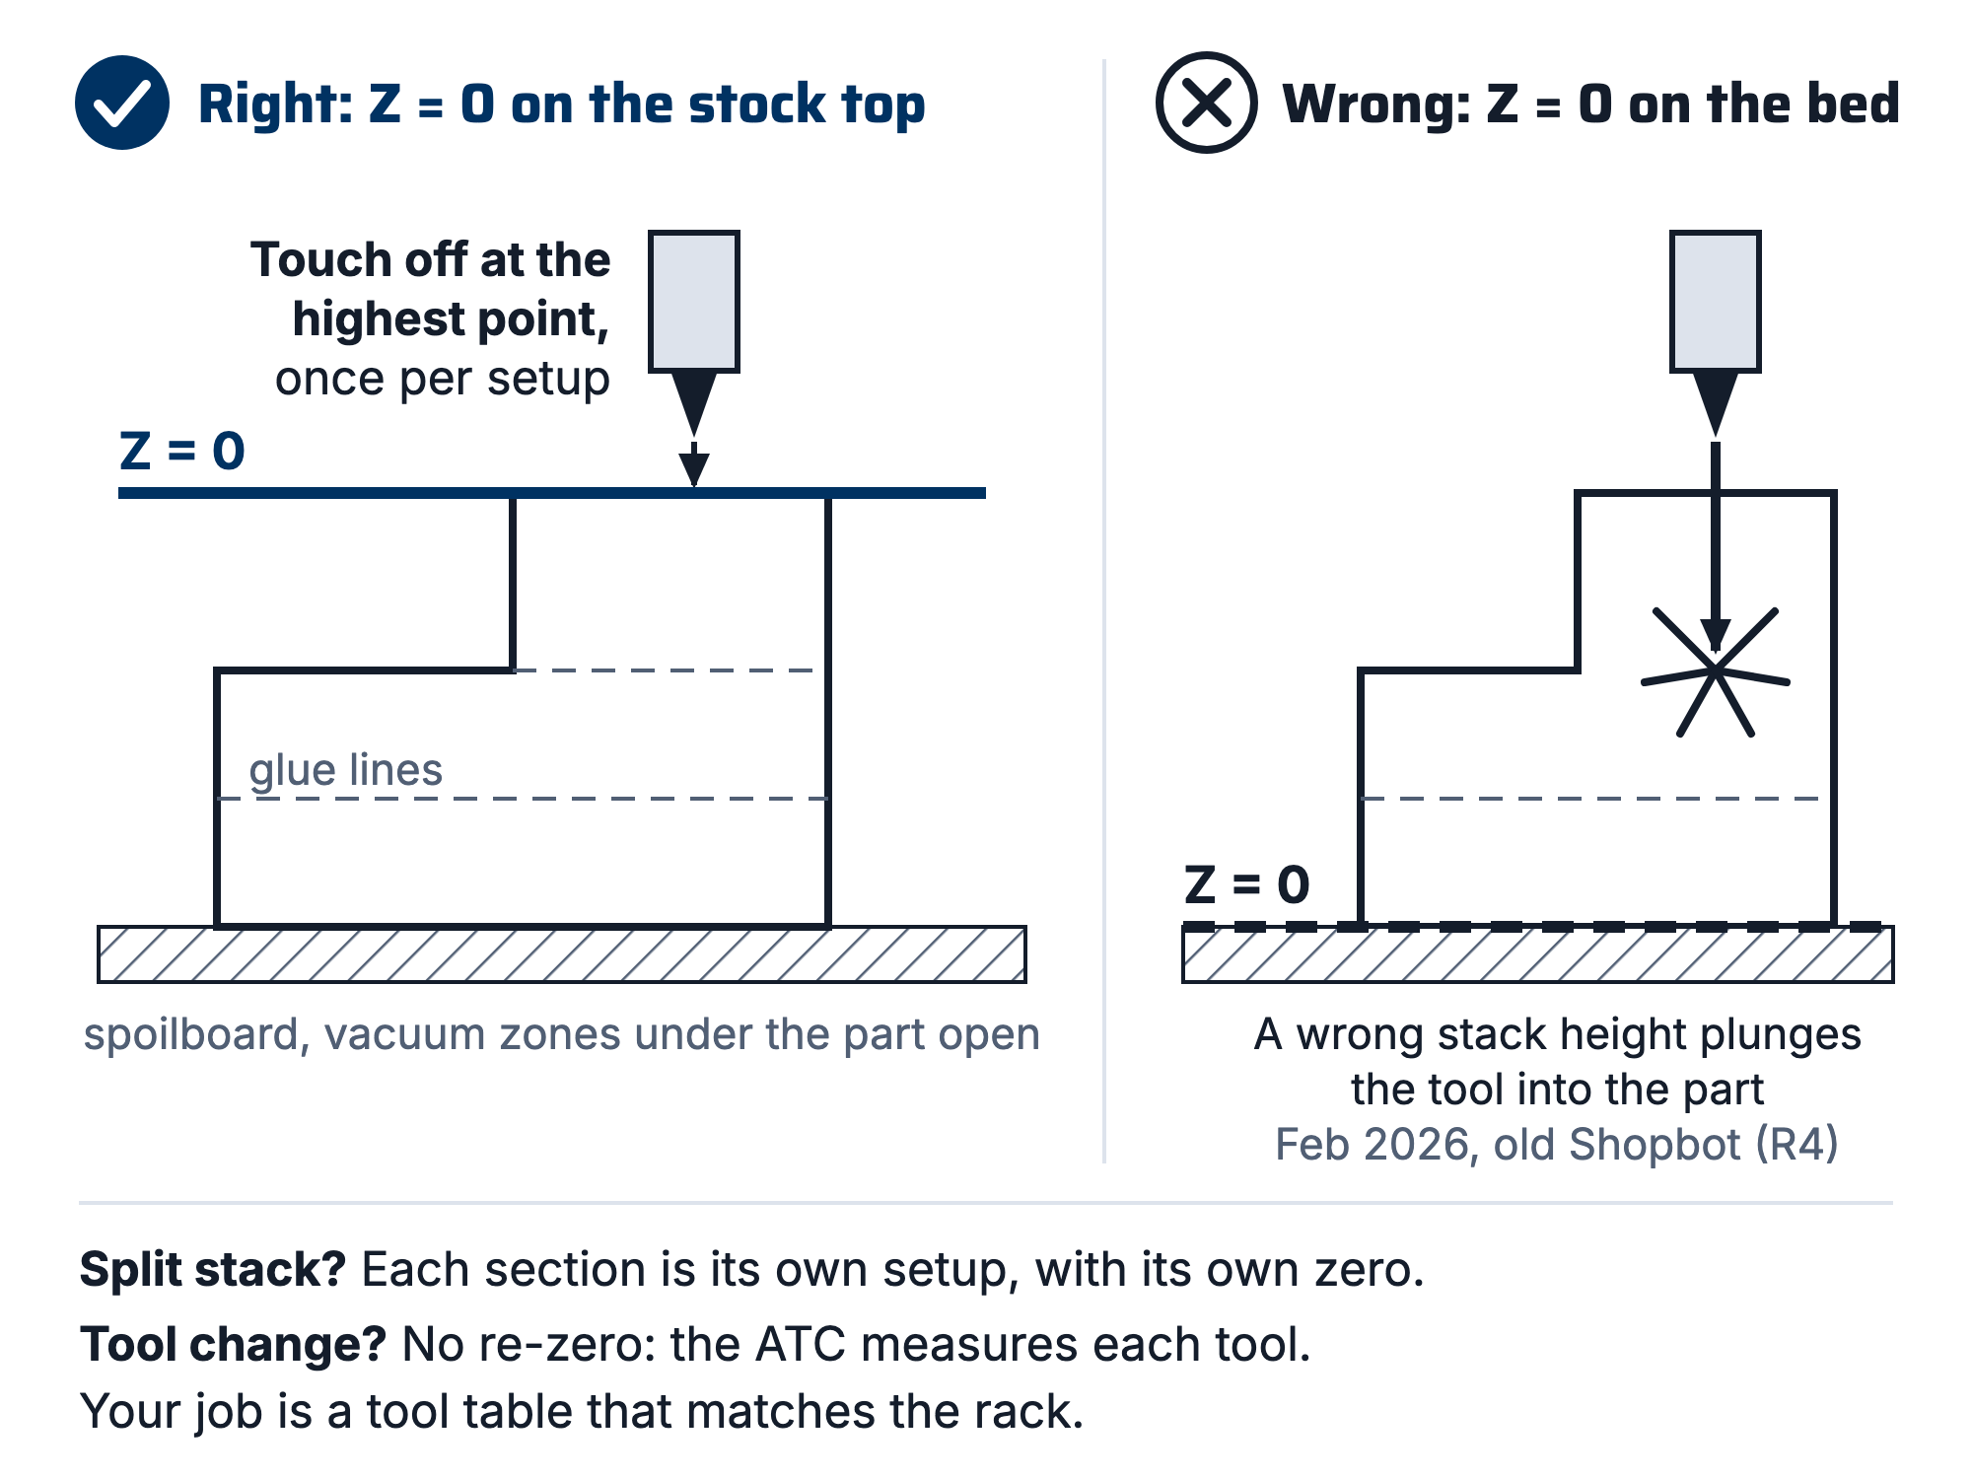
Figure 1. Z-zero, right and wrong. Left: touched off once per setup at the highest point of the stock. Right: zeroed at the bed, where any error in assumed stack height is a plunge into the part.

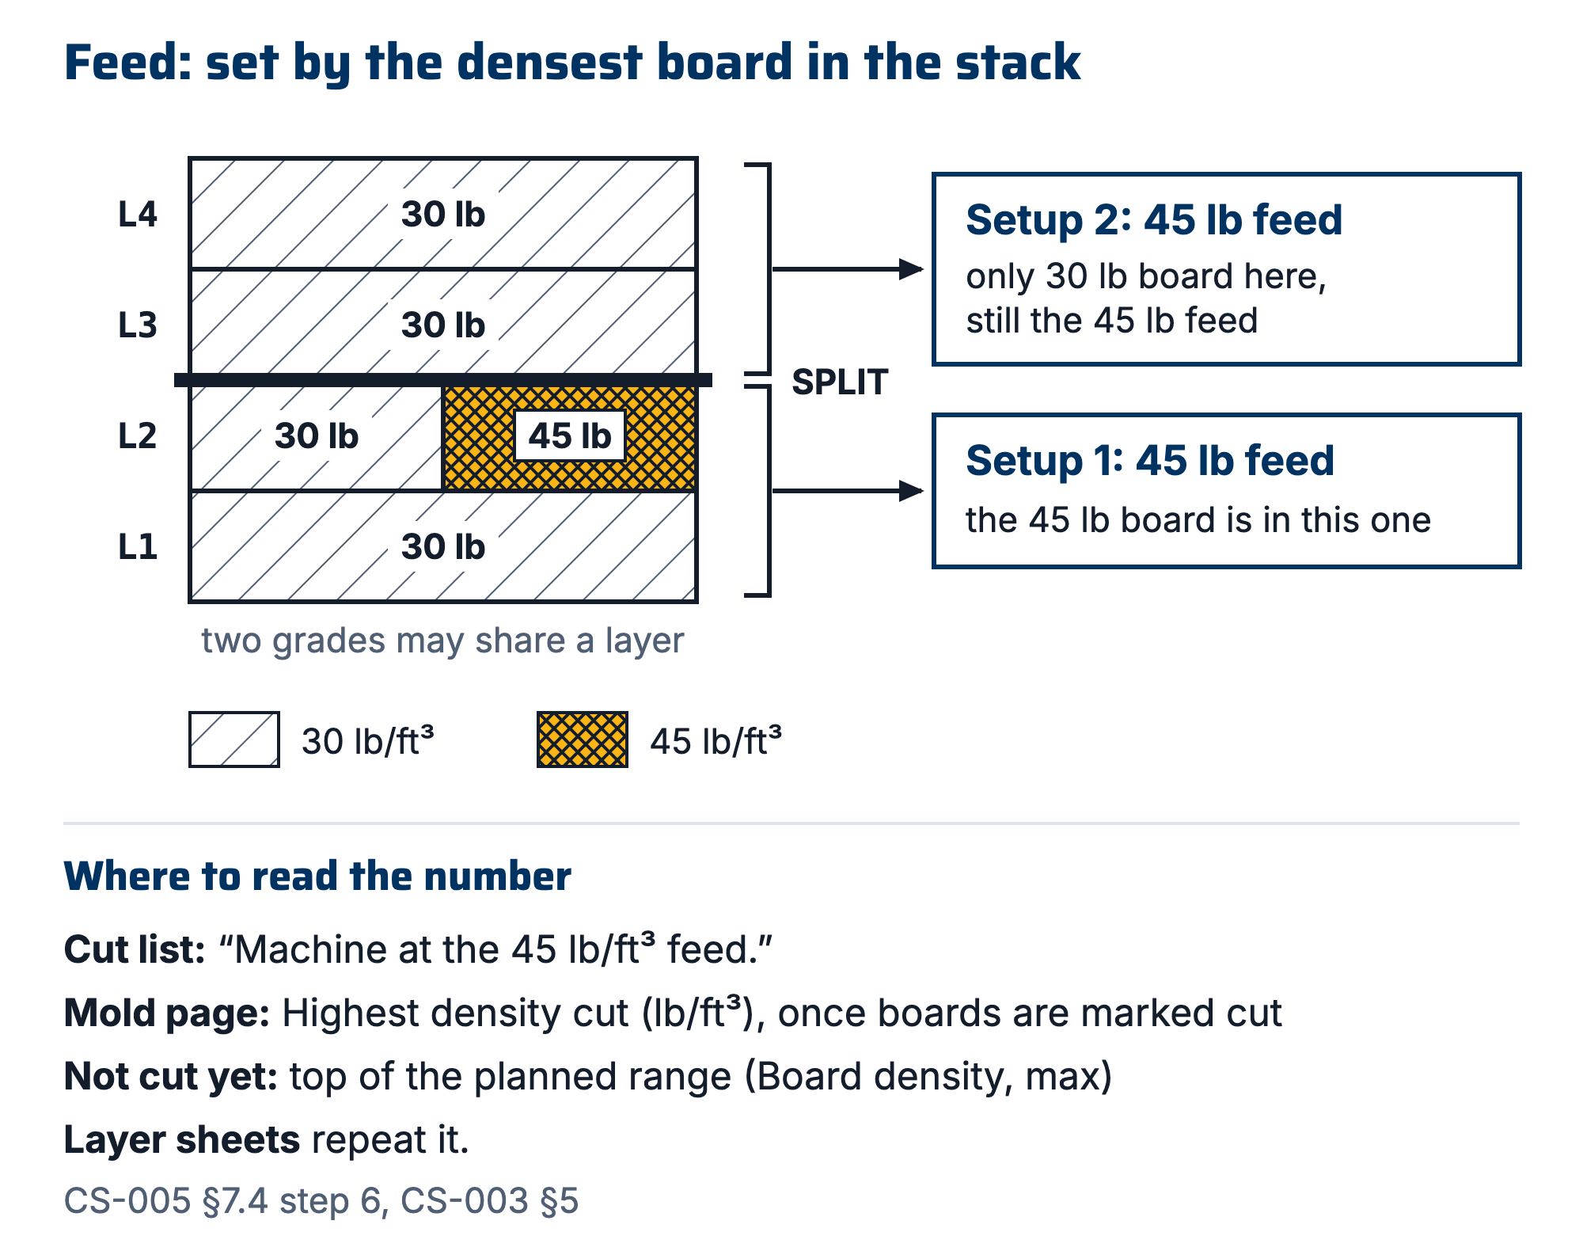
Figure 2. Feed rate for a mixed-grade stack: a mold glued from 30 and 45 lb/ft³ boards is machined at the 45 lb feed, because the densest board cut sets the feed for every setup.

7.5 During the run, engraving the ID and cleanup
- Stay with the machine; dust management per RFS rules.
- Record actual machining time in the work order's Machine mold step note (this is how next season's estimates get good).
- Check scribes/surfaces before releasing the vacuum; rework is easiest while the part is still located.
- Engrave the mold ID on the back face before releasing the vacuum: 6 mm cap height, 1.0 mm deep, single-line font, 3.175 mm ball or 90° V-bit. The machine is set up and the part is fixtured, so it costs about 90 seconds.
- Clean up, hand the room back better than you found it. The RFS relationship is our machining capacity.
- Set the mold's stage to Machined and its Home location in the app. Then clean and seal per CS-004.
⚠ CAUTION: The engraving is the record of record (CS-001 §7.4). It survives IPA, acetone, four coats of wax, PVA, sanding, the printed label falling off, and the label printer being broken. Every other way a mold is identified is a convenience wrapped around this one, which is why it is cut while the setup still exists rather than "later".

8. Quality checks / acceptance criteria
Check | Target | Method | Record where
Booking under actual operator | Always | Lead spot-check
Z zeroed from stock top (once per setup); tool table matches rack | Every run | Operator; buddy check on first solo runs | WO step initials
Hand-push test on tall/small-footprint stacks | Before every such run | Operator | WO step notes
First-cut watch | First 5 min minimum
Actual vs estimated machine time | Recorded | Machine log | WO Machine mold step note
Surface/scribe quality | Scribes crisp, no unexpected steps | Visual before releasing vacuum | WO qualityChecks

9. Records
The work order's Machine mold step note (Glue and machine mold on a wet-layup run): operator, date, slot, estimate vs actual, tool list, incidents. The app holds the step until it has a note, and suggests a photo (app/workorders.js). A lead can sign without it (Sign without it), and the reason goes in the work order's event log. The mold record: stage Machined and Home location (§7.5 step 6). Actual times feed the capacity model. ~2 molds/week was SN5 reality on a worse machine; find out what this one actually does instead of assuming.

Appendix: the Shopbot era (why this doc exists)
Jacobs Shopbot: per-person daily slots, ShopbotBot morning scramble, 3-reservation caps, trading slots with other teams, a ~3″ cut depth that forced tall molds to be sectioned and re-glued, manual tool changes with a re-zero every time, and tape/nail workholding (tape thickness literally showed up as Z error across a sheet). We out-demanded the system, block-booked through multiple members, and on 2026-02-23 Jacobs staff formally objected. The ShopSabre fixes the access problem and most of the setup failure modes: vacuum table kills the tape-Z-error problem, the ATC kills the forgot-to-re-zero problem, 6″ of cut depth kills most mold sectioning. It does not fix physics, though; one machine, bursty demand. The habit that transfers is forward capacity planning: estimates on WOs, booking at CAM start, machine load in the weekly summary.

